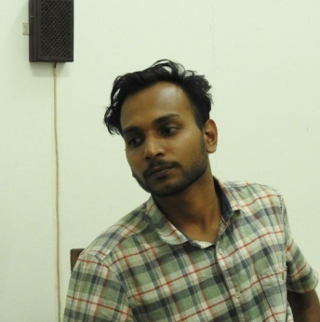

ALI AKBAR PN

7902570504
aliakbarn347@gmail.com

Current Address
133, Nandanvan Society, Abhilasha – Canal Road,
Abhilasha Char Rasta, New Sama, Vadodara, Gujarat – 390024

Permanent Address
Puthuveettil House, Koolimuttam P.O, Thrissur Dt, Kerala – 680691

Education
MVA (Painting), MSU Baroda, Vadodara, Gujarat (2018-20)
BFA (Painting), Govt. College of Fine Arts Thrissur, Kerala (2014-18)

Exhibitions
Imaginarium 2.0, Emami Art, Kolkata (2022)
From Where All That Sweat? Curated by Niranjana Surendran, Trivandrum (2022)
The Flying Goat Show Curated by Shyamli Singbal, Goa (2022)
Open Studio, Baroda (2021)
Untitled III Online Exhibition, Priyasri Art Gallery Mumbai (2020)
Nasreen Mohammedi Studio Display, MSU Baroda (2019, 2020)
Prologue 18 Final Display, Govt. College of Fine Arts Thrissur (2018)
Kala Mela Art Exhibition, Lalith Kala Academy, New Delhi (2018)
Print Premises Print making Exhibition Curated by Sunil Lal TR, Calicut (2017)
Group Show in Onyx Art Gallery, Kochi (2017)
Charcoal Group Art Exhibition, Calicut (2017)
Kasthuri sreenivasan Trust Annual Show, Coimbatore (2017)

